Project Design Phase
Solution Architecture
Date | 28 September 2026
Team ID | SWTID-2026-5471
Project Name | AI Study Buddy
Maximum Marks | 4 Marks
Solution Architecture:
Solution architecture is a complex process – with many sub-processes – that bridges the gap between business problems and technology solutions. Its goals are to:
- Find the best tech solution to solve existing business problems.
- Describe the structure, characteristics, behavior, and other aspects of the software to project stakeholders.
- Define features, development phases, and solution requirements.
- Provide specifications according to which the solution is defined, managed, and delivered.
Solution Architecture Diagram:
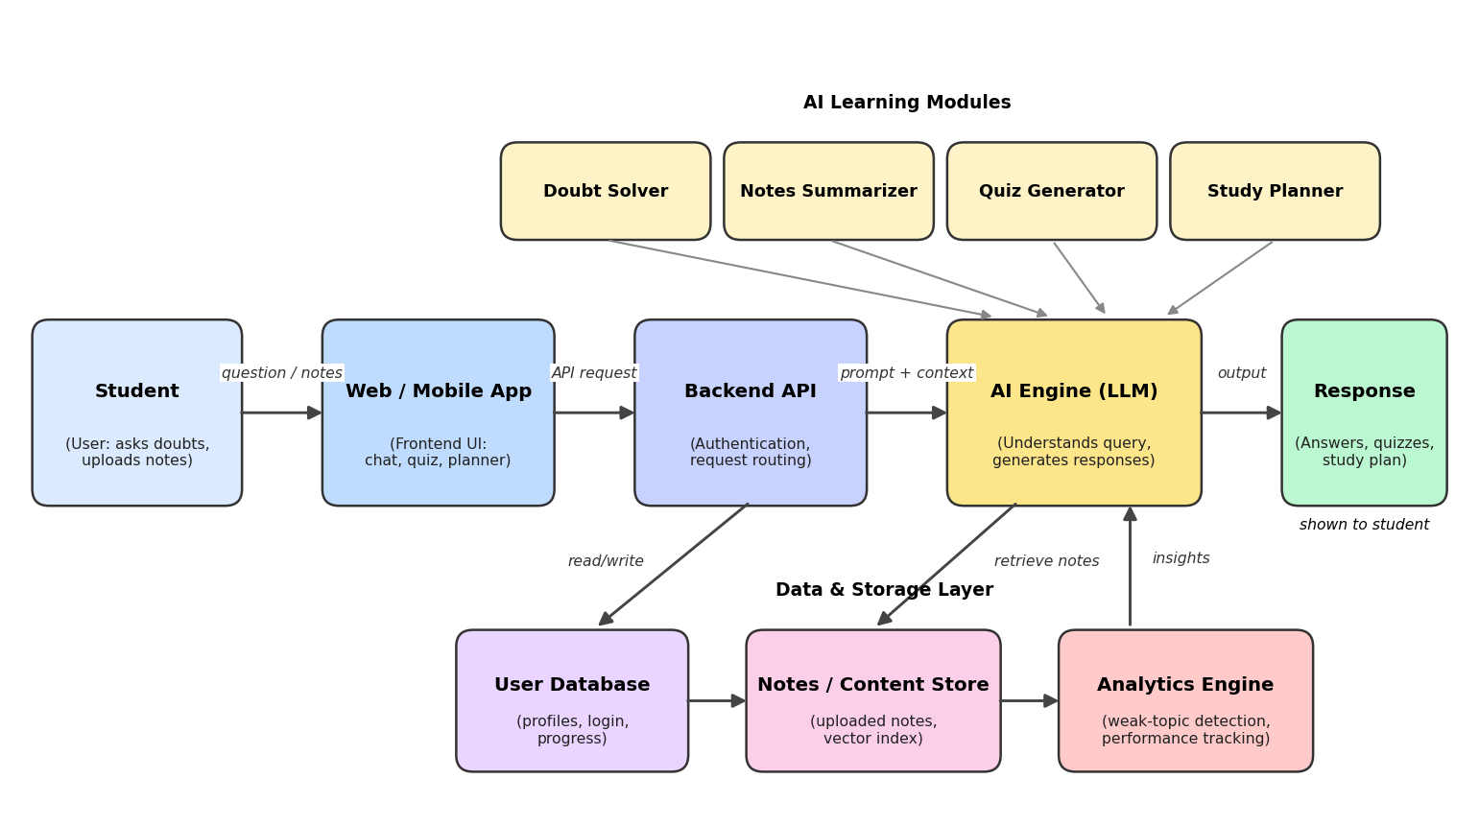
Figure 1: Architecture and data flow of AI Study Buddy

